Paul Collado
CSC-208-60
Sept 22, 2010

FrmColladoCh02Page91
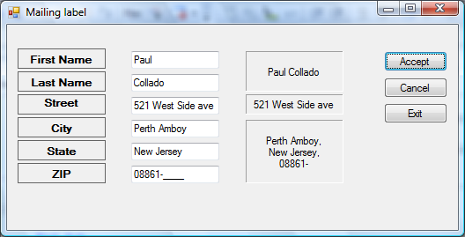

Public Class FrmColladoCh02Page91

Private Sub TxtFirstName_TextChanged(ByVal sender As System.Object, ByVal e As System.EventArgs) Handles TxtFirstName.TextChanged

End Sub

Private Sub BtnDisplay_Click(ByVal sender As System.Object, ByVal e As System.EventArgs) Handles BtnDisplay.Click

Me.LblFullName.Text = Me.TxtFirstName.Text + " " + Me.TxtLastName.Text
Me.LblStreetAddress.Text = Me.TxtStreet.Text
Me.LblCityStateZip.Text = Me.TxtCity.Text + "," + vbNewLine + Me.TxtState.Text + "," + vbNewLine + Me.MskTxtZip.Text

End Sub

Private Sub LblFullName_Click(ByVal sender As System.Object, ByVal e As System.EventArgs) Handles LblFullName.Click

End Sub

Private Sub LblCityStateZip_Click(ByVal sender As System.Object, ByVal e As System.EventArgs) Handles LblCityStateZip.Click

End Sub

Private Sub BtnClear_Click(ByVal sender As System.Object, ByVal e As System.EventArgs) Handles BtnClear.Click
Me.TxtFirstName.Clear()
Me.TxtLastName.Clear()
Me.TxtStreet.Clear()
Me.TxtStreet.Clear()
Me.TxtState.Clear()
Me.TxtCity.Clear()
Me.MskTxtZip.Clear()
Me.TxtFirstName.Focus()

End Sub

Private Sub BtnExit_Click(ByVal sender As System.Object, ByVal e As System.EventArgs) Handles BtnExit.Click
Me.Close()
End Sub
End Class

